San Diego County TJC Initiative Structure

Data and Evaluation

Transition and Community Supervision

   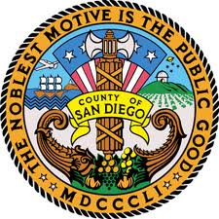   

Program and Curricula

Workgroup 4

Outcome Measures/Evaluation

Workgroup 3

Intervention and Evidence Based Practices Supervision Services

Workgroup 2

Alternative Sentencing

(part of workgroup 1 & 3)

Community Corrections Partnership (CCP) Executive Committee

Chair – Chief Probation Officer Mack Jenkins

CCP Steering Committee

Chair – San Diego Superior Court Special Projects Manager Scott Brown

Workgroup 1

Pre-Trial Custody, Process, and Disposition

CCP Subcommittees

Screening and Assessment

Transition from Jail to Community

Core Team

Chair – San Diego Sheriff's Department Captain Billy Duke