BASELINE DATA ENTRY INSTRUCTIONS FOR ACCESS

I. Opening the Database

1. Open the Access file entitled Baseline Data Summary.

2. Locate menu on the left containing folder options labeled Baseline Data Summary 1,2,3,4. Double click on each of the four data summaries to open them.

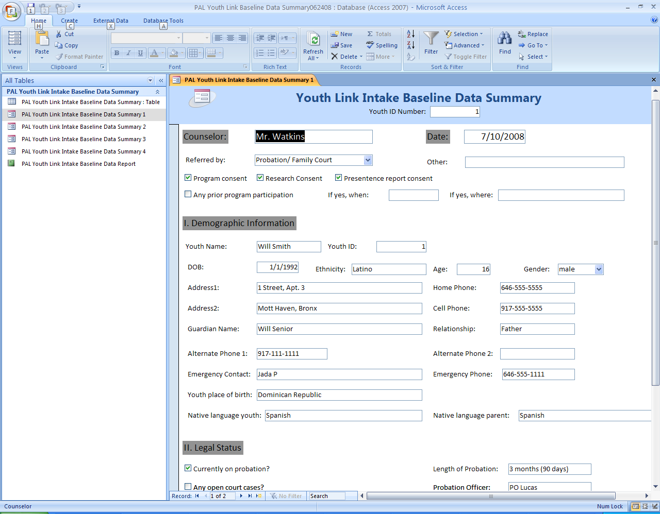
3. You are now ready to enter data. Note the highlighted Intake Baseline Data Summary 1 tab located near the top of the screen. This is the first page of your data entry form.

II. Data Entry
1. Start by entering the ID Number at the top of the screen. The numbers will serve as a permanent record for each individual case as they are entered. Press the enter key. Note that the ID Number will automatically be displayed in the Demographic Information field. Press the tab function key to scroll to different fields and enter data accordingly.

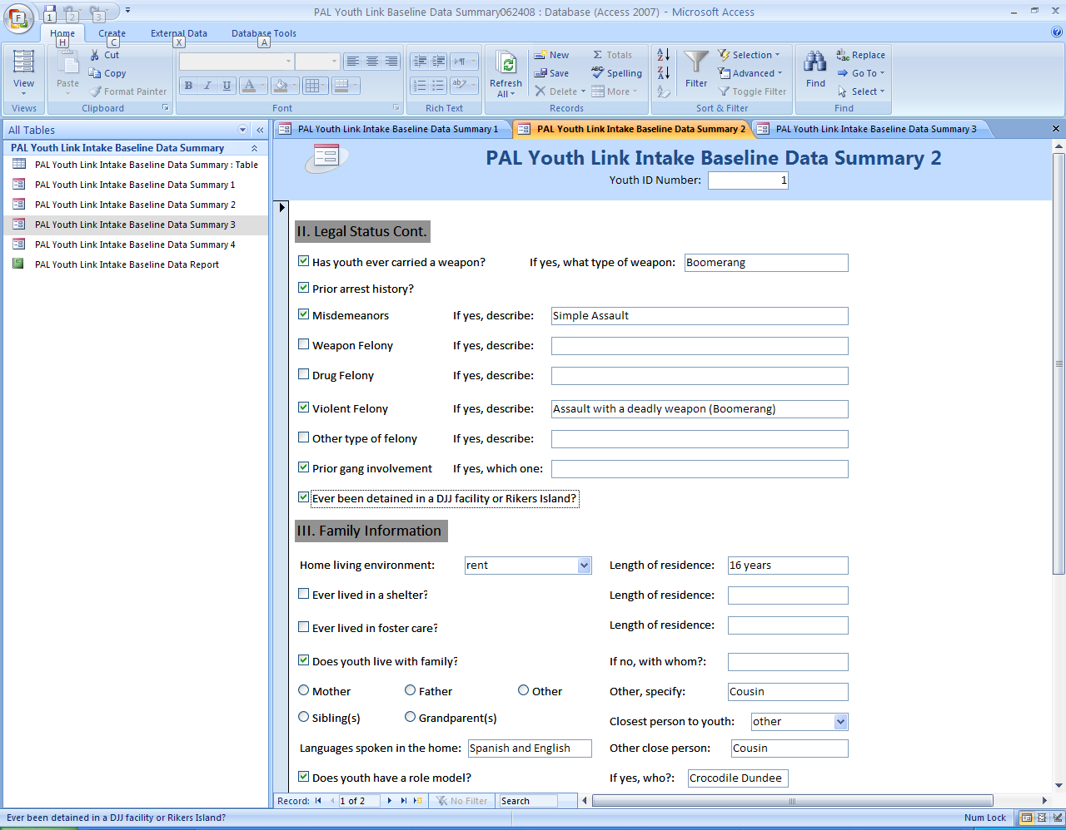
2. Once you have completed Summary 1, click on Intake Baseline Data Summary 2 and continue entering data.

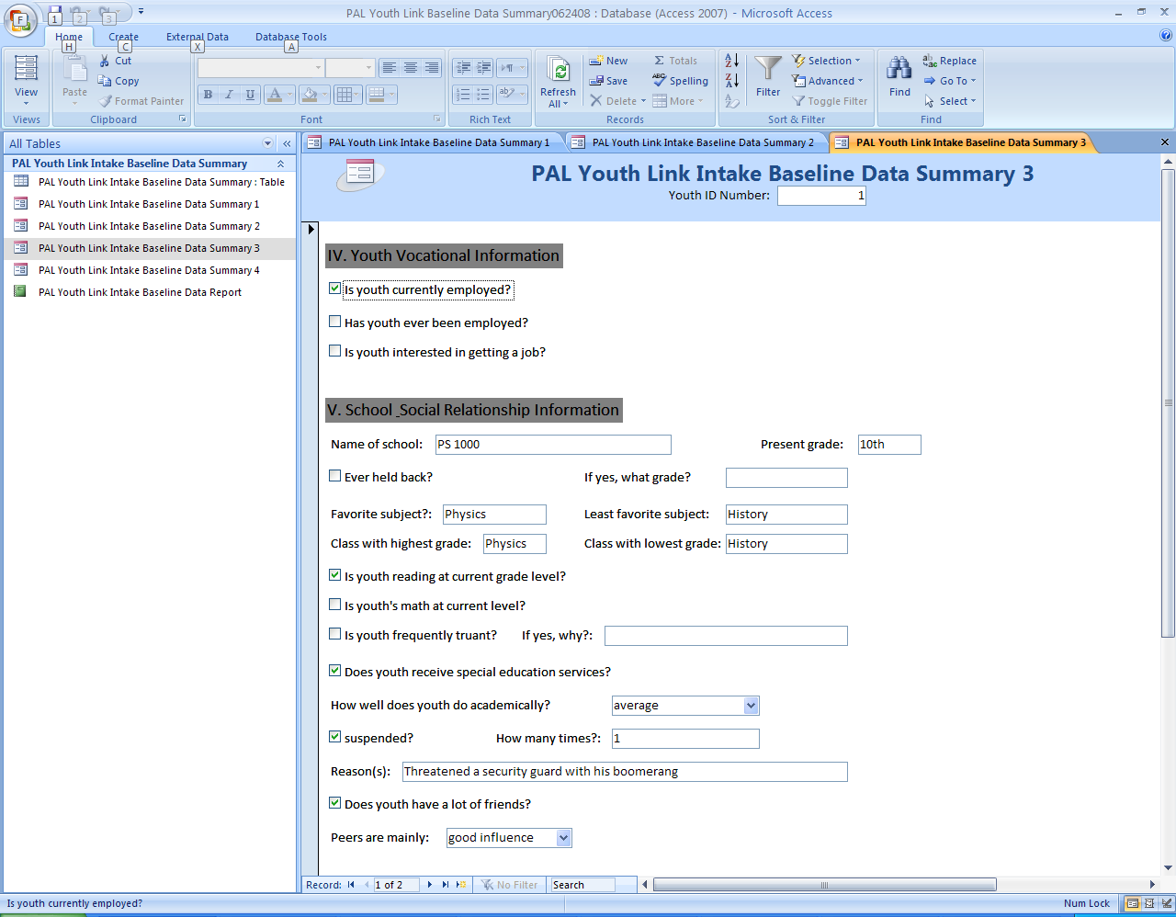
3. Once you have completed Summary 2, click on Intake Baseline Data Summary 3 and continue entering data.

4. Once you have completed Summary 3, click on Intake Baseline Data Summary 4 and continue entering data. The Notes section at the bottom of the screen allows you to write up to 255 characters. (This is the maximum amount that is allowed.)
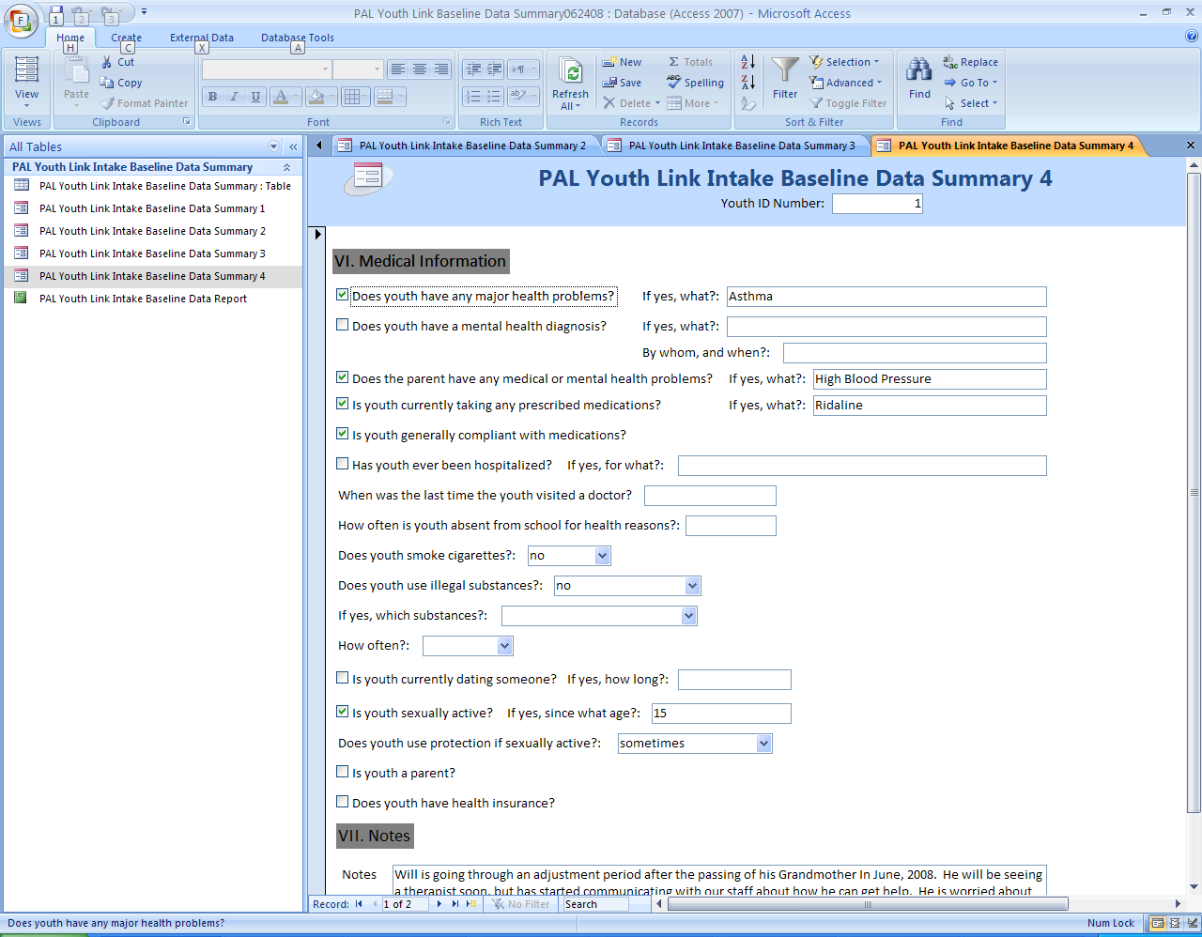

III. Saving Data

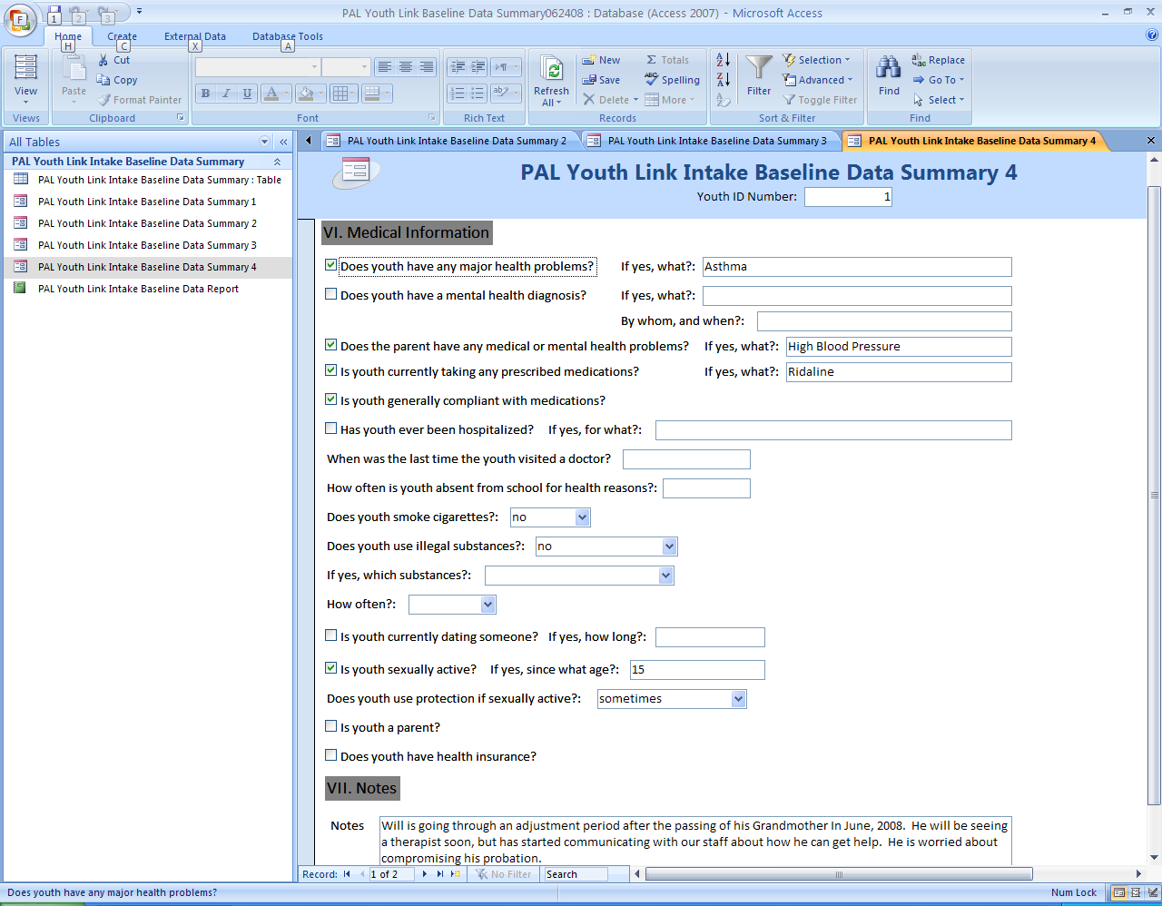

1. Now that you have created your first data set, you will need to save the information. There are two ways to do this. The top left corner of the screen has a save option, which you can click on. Alternately, you can click on the Record arrow located at the bottom of the screen to move to the next record. This option also allows you to navigate between cases. Continue to enter cases as described in Section two of this manual.

